**Communism – SPRINT 2 DELIVERABLE**

https://github.com/rockaflacka47/Communism/

8 NOV 2017

|  |  |  |
| --- | --- | --- |
| Name | GitHub | Title |
| Conor Lamb | Pere5troika | Scrum Master |
| Dave Rocker | rockaflacka47 | -- |
| Signe Ruprecht | SigneRuprecht | -- |
| Dalton Scharff | daltonscharff | -- |

# User Story Task Network

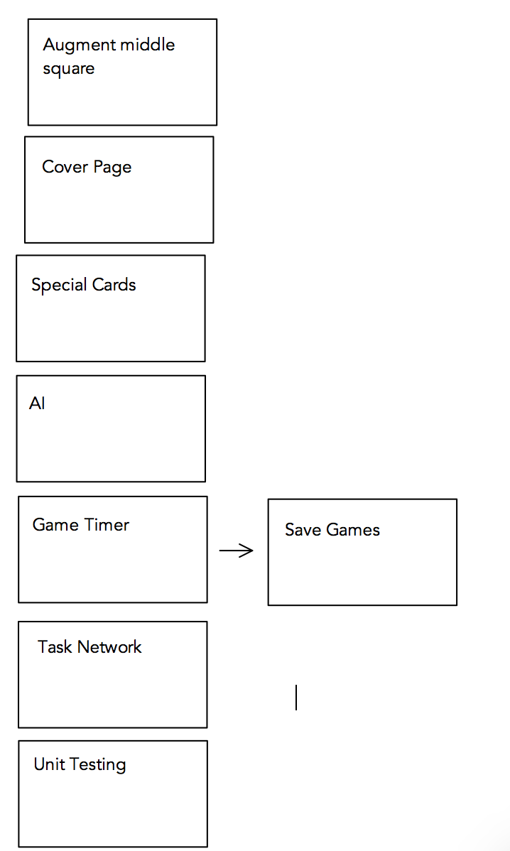

# User Story Assignment

**Conor:**

As a developer, I want a suite of unit tests, so that I can easily identify what section of code is failing. – 8 points.

As a player, I want to be able to save my game, So that I can come back to it at a later time. - 8 points

As a scrum master, I want a task network, so that we can prioritize tasks. – 4 points

As the product owner, I want a cover page, so that we know who is working on the project. – 2 points

**Dalton:**

As a developer, I want a suite of unit tests, so that I can easily identify what section of code is failing. – 8 points.

As a player, I want a more visually distinct middle square, so I know where I'm jumping to. – 2 points

**David:**

As a developer, I want to implement 5 skip turn cards, So that it makes the game more interesting and not as predictable. - 8 points

As a developer, I want to implement 3 go to middle cards, So that the game is more interesting. - 8 points

**Signe:**

As a player, I want the ability to take turns with other players and see my token move to the appropriate square, So that I can see my own progress as well as the progress of other players. – 16pts